Remote Aboriginal Governance and
Capacity Building Grant Program
Application form

Applicants should read the guidelines carefully before completing this form.

Organisation Details
Organisation legal name:
Postal address |  |  |  |  |  |  |  |  |  |  |  |  | Postcode
Street address |  |  |  |  |  |  |  |  |  |  |  |  | Postcode
Telephone: |  |  |  |  |  |  |  |  |  |  | Mobile:
ABN: |  |  |  |  |  |  |  |  |  | GST registered |  |  |  | Yes No
Incorporated association |  |  |  |  |  |  | Unincorporated
Not for Profit organisation |  |  |  |  |  |  | Office of the Registrar of Indigenous Corporations
Other (please state) |  |  |  |  |  |  | ________________________________

Contact Officer Details
Mr Mrs Ms Miss Other
Full name:
Position in organisation:
Telephone:
Email address:
Grant  (under 20K) |  |  |  |  |  |  |  |  | Grant  (between 20k-50k)

Location
Please indicate the region in the Territory where your organisation conducts its main activities (you may select more than one region if applicable).
For the purposes of the program, remote is defined as being outside of the key population centres of the Northern Territory including Greater Darwin, Nhulunbuy, Katherine, Tennant Creek and Alice Springs, and is inclusive of homelands/outstations and/or town camps.
Organisations and/or projects must be based in remote areas.
Top End Region (incl. Tiwi Islands, Jabiru, Maningrida)
East Arnhem Region
Big Rivers Region
Barkly Region
Central Region

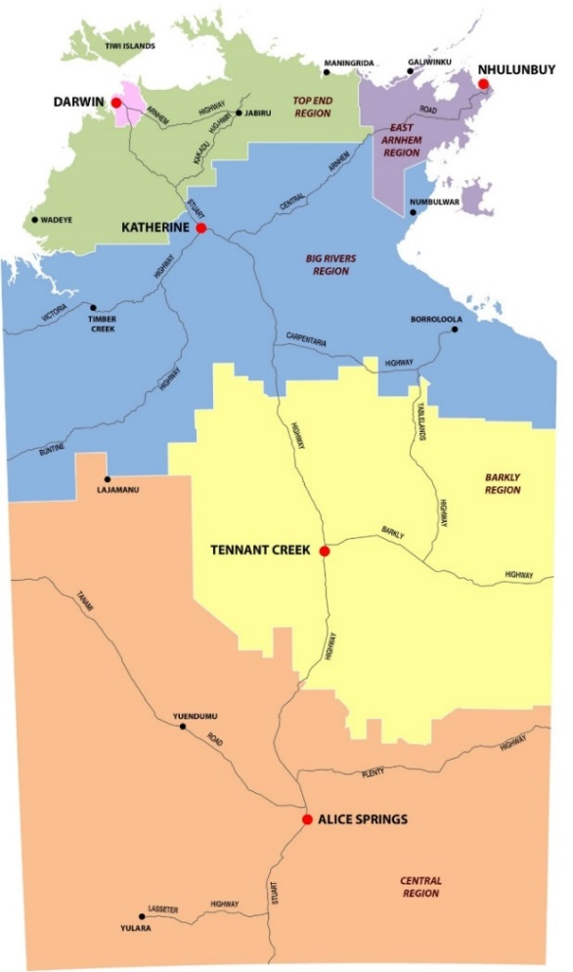

Please indicate which regional location that will benefit from the grant (you may select more than one region if applicable).

Top End Region (incl. Tiwi Islands, Jabiru, Maningrida)
East Arnhem Region
Big Rivers Region
Barkly Region
Central Region

Community Location_____________________________________

Activities of the Applicant Organisation
Please briefly describe the activities and services provided by your organisation to the community. (If more space is required please attached it separately)

Summary of Grant – Detailed overview of Projects Should be Attached Separately
Project Title:

Provide a summary of the grant and include benefits to Aboriginal people in terms of governance, leadership and community capacity building

What community support and / or involvement does your project have?
Approved Provider (outline of provider you maybe be engaging)

Performance Indicators
What are the expected outcomes? |  |  | How will you know if these outcomes have been achieved?
For example, provide Leadership training to youth |  |  | - Number of sessions conducted  - Number of attendees

Please indicate the target group for your project by ticking one of the boxes below
Older people | Carers | Families
Women  Young People | Children  Whole of Community | Men

Proposed Budget for this Application
Please summarise your budget requirements and provide a detailed budget attached to this application and please attach quotes
Budget |  |  |  |  | Total Cost $ (GST Excl.)
Total project cost:
Less organisation’s contribution to project (if applicable)
Less funds to be raised (if applicable)
Total amount sought:
If unable to obtain any Territory quotes please explain why?
If full funding is not available would you like your application considered? Yes No

Other Funding
Does your organisation currently receive funding from Commonwealth, Territory or local government sources? (including non-government sources)
Yes No If Yes, please specify:

Program |  |  | Amount $
Have you applied or are you going to apply for any other funding in relation to this project?
Yes No If Yes, please specify:

Agreement and Declaration
I certify that the statements in this application are true.

I acknowledge that if the grant is approved, I will be required to meet the eligibility criteria.
I acknowledge that the grant may vary and the level of funding provided through the
program is at the Departments sole discretion.
There is no guarantee funding for any application, and cannot guarantee funding to
the full amount requested by any applicant.

I have been authorised by |  | to make this application.
 | (name of organisation)
Full name
Position in organisation:
Signature:
Date:

Grant application checklist
Before submitting your application, please use this checklist to ensure your application is accurately completed. Incomplete applications will not be considered.
Have you confirmed that your organisation is eligible to apply? (i.e. Not for Profit)
Have you provided your organisation’s details including your ABN and GST information?
Have you indicated the region and or communities where the funding will be utilised?
If your group is not incorporated, have you provided details of your sponsor?
Have you completed the project description and given details of your budget?
Have you included quotes for all the budget items listed in your application?
Have you advised us of other sources of funding your organisation may receive?
Have you indicated the target group for your project?
Have you provided the name of your Accountable Officer and have they signed the
application form?
Have you kept a copy of your application for your organisation’s internal records?

Submitting your Application
Please send completed applications via email (preferred method), post or delivered to Aboriginal Affairs Strategic Partnerships via:
Email
oaa@nt.gov.au

Post:
Aboriginal Affairs Strategic Partnerships
Darwin Office Alice Springs Office
GPO BOX 4396 GPO Box 2605
DARWIN NT 0801 ALICE SPRINGS NT 0871

Remote Aboriginal Governance and Capacity Building Grant Contact Details

Telephone: (08) 8951 5183
Email: oaa@nt.gov.au
Web: www.nt.gov.au

